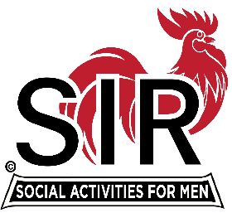
INCORPORATED
LAS TRAMPAS BRANCH 116
ZOOM MEETING

BRANCH EXECUTIVE COMMITTEE MEETING
May 4, 2020

Big Sir Michael Barrington requested the meeting to discuss the status and requirements for all Branch 116 Sport Type Activities in the near future.

Those on the call were:

Big SIR Michael Barrington
Little SIR Sam Beret
Secretary Fred Schafer
Assistant Secretary Paul Ramacciotti
Treasurer Alan Fitzgerald
Assistant Treasurer Al Satake
Membership Phil Goff

Directors
Dave Harris
Roger Craig
Gary Boswell
Al Farbman
Fred Wachowicz

Also on the call was Department Head: Don Schroeder and Committee Chairmen: Neil Schmidt, Mike Ward, Bernie Wroblewski, Alex Lutkus and Jim Barstow.

Michael reviewed all the current Due Diligence requirements of the State SIR’s before an Activity or contact event may be held. Today, we spoke specifically about golf. Michael explained that before any golf event occurs the Golf Committee must have a complete understanding of that golf courses requirements to keep the individual golfers safe from Covid 19. The Committee must then present the specific requirements to the BEC and then the BEC must vote yea or nea regarding whether that specific event is approved. The event may not take place any sooner than 30 days following that vote. These same requirements apply to ALL other SIR Branch 116 Activities in the near future. All BEC members attending this meeting now have a better understand of these requirements.

Bernie Wroblewski and the Golf Committee will meet to come up with a proposal for how we, as a branch, can have golf events in the future.

On another subject, Al Farbman reported that the author of Code Breaker has agreed to speak with the Branch via ZOOM on May 18 at 10:00. Neil Schmidt will put together the hosting for the speech. There will be a BEC meeting starting at 8:45 with the Open Meeting starting at 9:45 and the speaker at 10:00.

Fred Schafer, Secretary

Executive Committee
Area 16 Governor
Region 5 Director
All Support and Activity Chairmen

